Example letter to parents

Dear Parents/Guardians
[Parents Evening / Meeting Title]
We are holding a Parents' Evening for parents/guardians of students in [Yeargroup] on [Date]. The purpose is to enable you to discuss your son's/daughter's work and general progress with his/her tutor and teachers
We have has introduced an easy to use online appointment booking system. This system allows you to choose your own teacher appointment times. You will shortly receive an email invitation to activate your account. If you do not receive your invitation email, please contact the school. We are confident this system will be an improvement over our previous booking arrangements.
The appointment system and invitation email goes live at [Publish Date, Time]. Please note, appointments will be made on a first come first served basis and each appointment will also include 5-minute movement time.
Please see the guide on how to make appointments below.
If you do not have access to the internet or there is an issue logging in, then please contact the school office who will be happy to help or add appointments on your behalf.
We look forward to seeing you.
Kind Regards

How to book an appointment
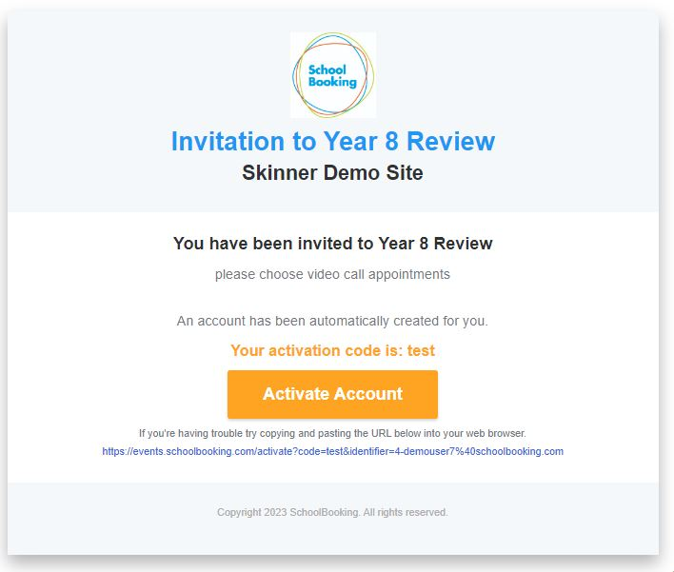
Step 1 – Activation Email & Login
Use the link provided in your activation email. This will open your browser to https://parents.events.schoolbooking.com/
From here ‘Activate’ your account and setup a new password.
Saving your new password will take you directly to the Events Dashboard (Step2)

Step 2 – Select the Parent Meeting/Event
When you first login to Parent Meetings the next event will be selected automatically for you. You can change to another event if needed.
Desktop view
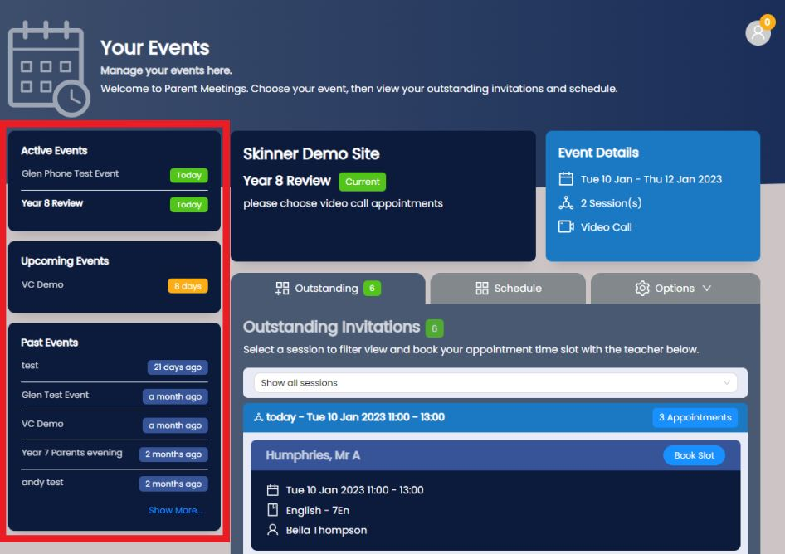
Mobile/Tablet view
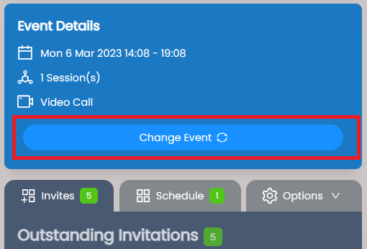
Step 3 – Choose the teachers/subjects and meeting times
Firstly, make sure you are viewing the correct Event (see Step 2). Choose the Invites tab to view your outstanding invitations. You will see a list of the available Teachers you can book with and the slots available. If your event has been setup by your school over a few different days, you can filter these 'sessions'. Choose from the available Teachers and select 'Book Slot'
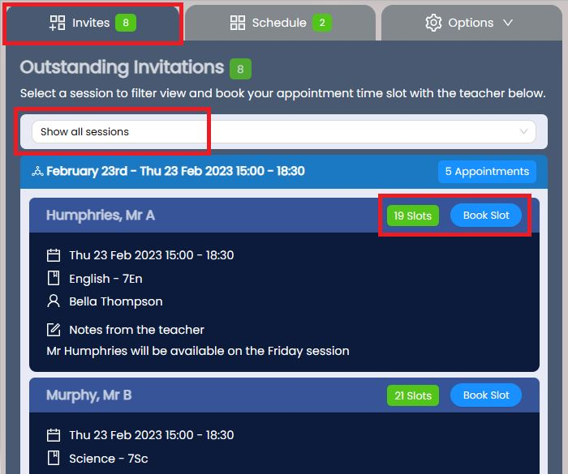
The available slots will be shown, along with any other bookings you have made so far. Select the time slot and you will see a confirmation and notification that your booking is now in your schedule.
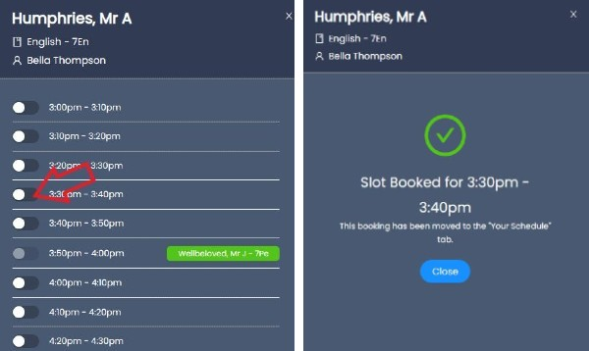

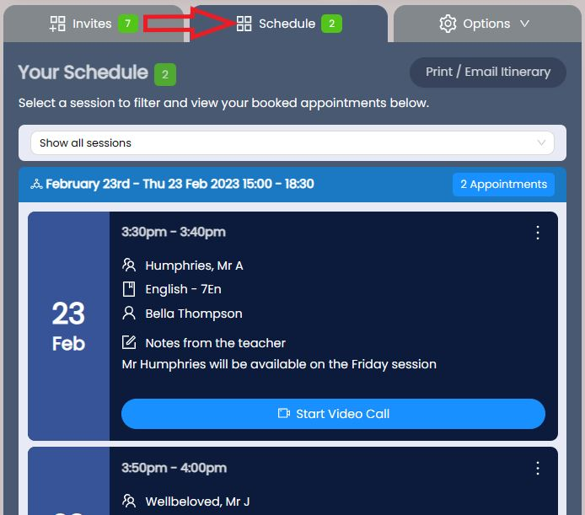
Make sure you have booked a time for every teacher you want to see and then print or email your itinerary ready to bring with you on the day.
You will also receive a reminder email with a copy your itinerary the day before your Parent Meeting.
Step 4 – Install Web App for faster experience.
This is optional, but will make it easier for you to find and manage your appointments in the future. Available for most devices. See this guide for instructions
Video Call meetings
For Video calls, please return to https://parents.events.schoolbooking.com/ on the day of the Parent Meeting and use Join Meeting links at the appropriate time. When the teacher sees you are connected, they will join the meeting. For the best experience we recommend you use a PC or Mac (with speakers and microphone), or a mobile device such as a tablet (iOS or Android). You can use the Join Meeting links at any time to test your device settings.
Please use the Parents Help Center for additional guidance.

